5.1 - Add and Subtract Polynomials

A monomial is the product of a constant with zero or more variables. The variables can have whole number powers: Examples: 6, -2x, -4a²b³c²

A polynomial is the sum of one or more of these terms. Example: 5x² + 2ab + 3x + 4

Based on the number of terms, we can classify polynomials
- monomial - one term
- binomial - two terms
- trinomial - three terms

Degrees
The degree of a term is the sum of the exponents on the variables
The degree of a constant is 0
The degree of a polynomial is the max degree of its terms

For the following, give the degree and classify them as mono/bi/trinomial if possible

14
8ab²
h + 7
-9x⁵y³
6m⁴ - m³n³ + 9mn⁶
4a + 2b + 3c - 5d

Combine like terms
3x + 5x + 1 + 6

Simplify a² + 7b² - 6a²

Find the sum (7y² - 2y + 9) + (4y² - 8y - 7)
Simplify (9w² - 7w + 5) - (2w² - 4)

Subtract (p² + 10pq - 2q²) from (p² + q²)

A polynomial function is a function whose rule is a polynomial
For f(x) = 5x² - 8x + 4, find the following

f(4)

f(-2)

f(0)

The polynomial function -16t² + 250 gives the height of a ball t seconds after it is dropped from a 250-foot tall building. Find the height after t = 2 seconds.
Adding and subtracting functions
(f + g)(x) is defined as f(x) + g(x)

(f - g)(x) is defined as f(x) - g(x)

For f(x) = 3x² - 5x + 7 and g(x) = x² - 4x - 3 find the following

(f + g)(x)

(f + g)(3)

(f - g)(x)

(f - g)(-2)

Section 5.2 - Properties of exponenets and scientific notation

Product property

Consider x² ⋅ x⁴

In general: a^{m} ⋅ a^{n} = ______

Simplify the following:

y⁵ ⋅ y ⁶

2^{x} ⋅ 2^{3x}

2a⁷⋅3a

Quotient Property

Consider How about

In general: = _______

Simplify the following

Zero Exponenets
Consider

In general: = _____

Simplify

9⁰

x⁰

2x⁰

(2x)⁰

Negative exponents

Consider

In general, = ______

Consider

In general = ________

Simplify
x⁻⁵

10⁻³

Consider

In general = ________

Simplify

z⁻⁵⋅z⁻³

(2x⁻⁶y⁸)(-5x⁵y⁻³)

Consider (x²)³

In general: = ______

Simplify

(y⁵)⁹

(y³)⁶(y⁵)⁴

Consider (2x)³

In general: (ab)^{m} = ________

Simplify

(-3mn)³

(-4a²b)⁰

(6k³)⁻²

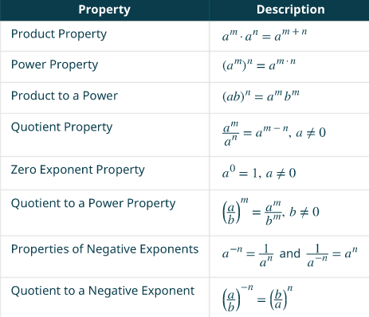
(5x⁻³)²

Consider

In General:

Simplify

Section 5.3 - Multiply Polynomials
Simplify
(3x²)(-4x³)

Multiply a binomial by a binomial
(y + 5)(y + 8)

(4y + 3)(2y - 5)

(x + 3)(x + 7)

(n² + 4)(n - 1)
Multiply a polynomial by a polynomial

Simplify (b + 3)(2b² - 5b + 9)

(y - 3)(y² - 5y + 2)

(x3 - x + 4)(2x² - 3x + 5)

Multiply special products
What patterns do you see in these?
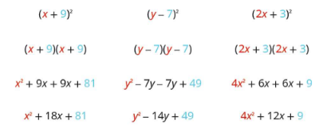
In general (a + b)² = ____________

(a - b)² = _____________

A pair of binomials that have the same first and second term but one is a sum and the other a difference is called a conjugate pair. Multiply (a + b)(a - b) to see what happens

(a + b)(a - b) = ____________
Use the difference of squares to multiply these
(2x + 5)(2x - 5)

(5m - 9n)(5m + 9n)

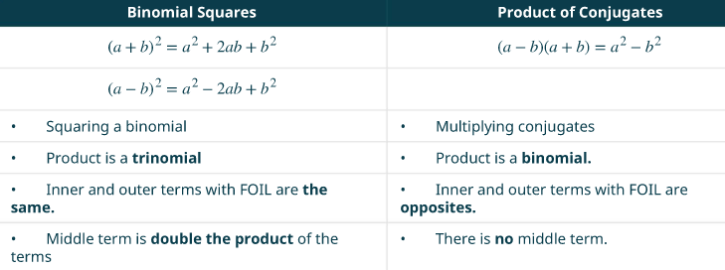
Simplify

(2x - 3)(2x +3)

(8x - 5)²

(6m + 7)²

Multiplying functions
(f⋅g)(x) = f(x) ⋅ g(x)

Consider the functions:
f(x) = x + 2

g(x) = x² - 3x - 4

Find (f⋅g)(x)

Find (f⋅g)(2)
Section 5.4 - Dividing polynomials

Find the quotient

Recall that for fractions

Simplify

Long division - to divide 875 by 25, it looks like this
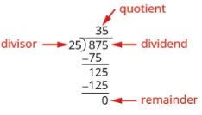

Use long division to find the quotient

Notice that there is no x³ term. Use 0x³ as a placeholder
Synthetic division makes the work easier
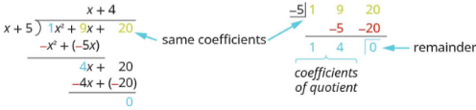
Use synthetic division to divide:

Use synthetic division to divide:

Dividing functions

For and

Find

The remainder theorem: If the polynomial function f(x) is divided by x - c, then the remainder is f(c)

Use the remainder theorem to find the remainder when is divided by x + 2

Verify by using synthetic division

Factor theorem: For any polynomial function f(x):
- if x - c is a factor of f(x), then f(c) = 0
- if f(c) = 0, then x - c is a factor of f(x)

Determine if x - 4 is a factor of f(x) = x³ - 64

Verify this with synthetic division

Determine if x - 5 is a factor of f(x) = x³ - 125

Determine if x - 6 is a factor of f(x) = x³ + 216

